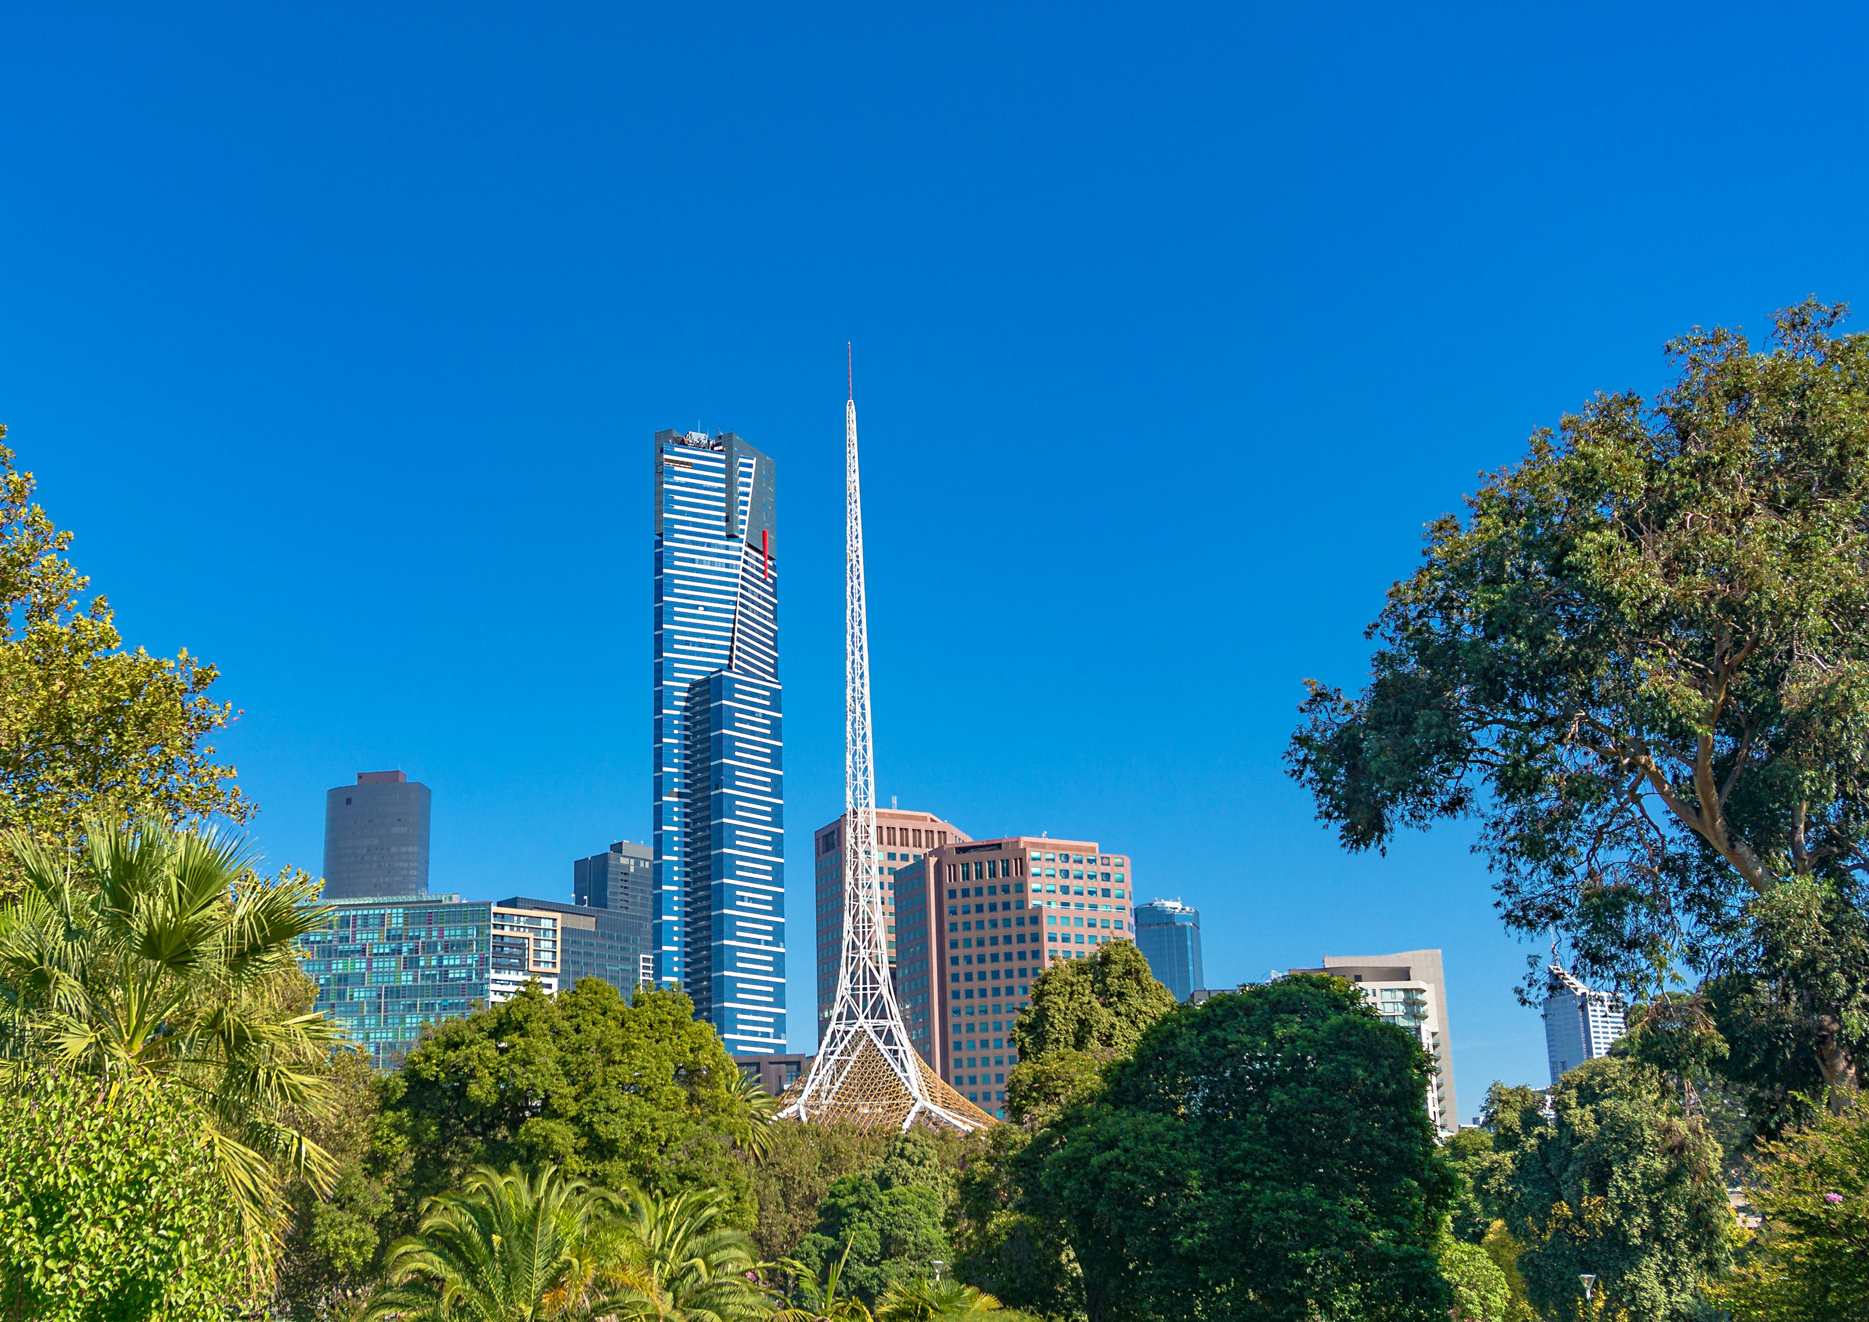2026 Conference MELBOURNE
Kwong Lee Dow Building at the University of Melbourne

JOINTLY HOSTED BY
2026

Welcome

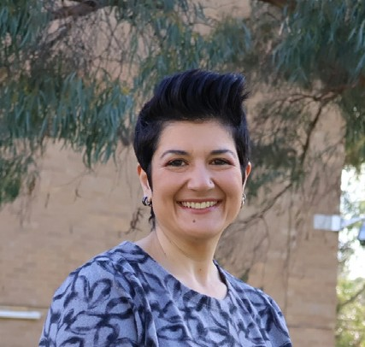
We look forward to welcoming you to Melbourne, Australia for the 2026 Australasian Society for Autism Research (ASfAR) Biannual Conference. I’m genuinely delighted to welcome our ASfAR community from across Australasia and beyond for two days of connection, conversation and sharing the work that is shaping the future of autism research.

A strong theme running through this year’s conference is the importance of whose knowledge we centre, whose voices shape our research, and how we build autism research and practice that is culturally grounded, inclusive and responsive to the communities it is intended to serve. This is reflected particularly strongly in our keynote program, which brings together Australian First Nations, Māori and Indigenous Pasifika perspectives, alongside community involvement and participatory approaches to autism research and practice. Across the broader program, I hope you will find opportunities not only to hear about new research, but also to reflect, challenge ideas, make new connections and reconnect with colleagues and friends. With such
a wonderful range of keynote, oral and poster presentations, there is an enormous amount of knowledge and experience being brought together over these two days.

This year’s conference is also particularly special as a collaboration between the University of Melbourne (UoM) Neurodiversity Project and the Olga Tennison Autism Research Centre (OTARC), La Trobe University. I have been very fortunate to co-chair the conference with Associate Professor Matthew Harrison. I want to sincerely thank Matt and the University of Melbourne for providing our conference venue and spaces, and for the enormous thought and care that has gone into making the conference as accessible as possible for all our presenters and attendees.

Finally, a huge thank you to the many volunteers who have contributed their time, thought and care to creating this conference. It simply would not have been possible without the generosity and commitment of so many people working behind the scenes. I hope these two days are a chance to connect, be challenged, share ideas, and enjoy being together as part of the broader autism research, practice and lived- experience community here in Melbourne.
Associate Professor Josephine Barbaro
President, Australasian Society for Autism Research

2026

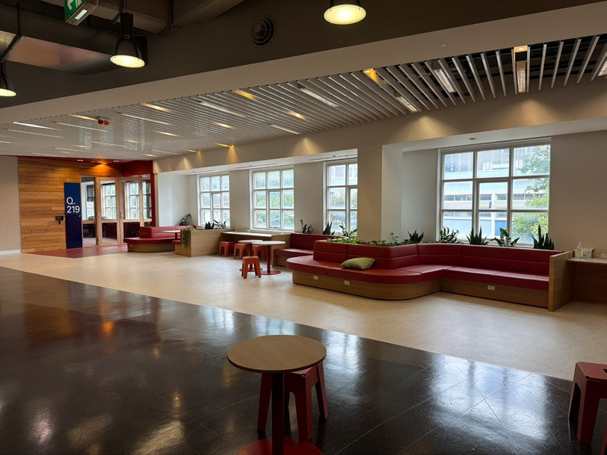
The 2026 ASfAR Conference will be held in the Kwong Lee Dow Building at the University of Melbourne, located at 234 Queensberry Street, Parkville VIC 3053. You may have already seen a video tour of the spaces that we will be using when you registered through Eventbrite.

The venue

Our welcome and reception space

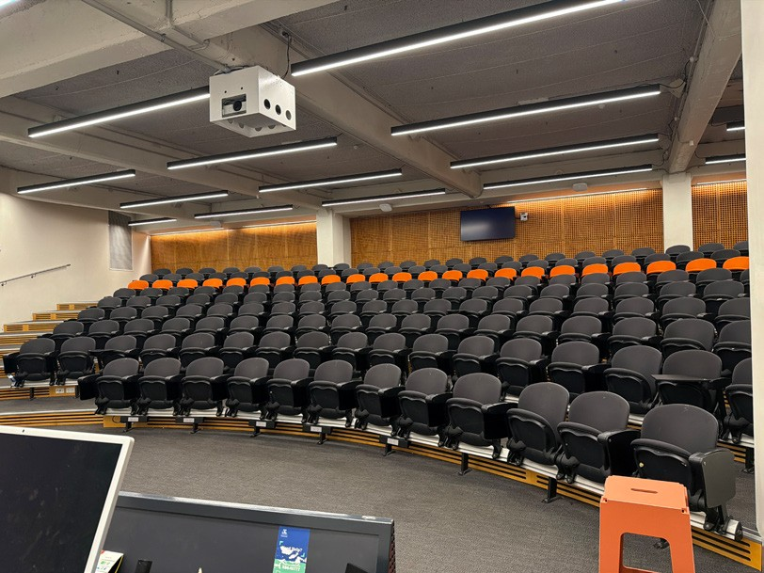
Our main lecture hall for keynotes

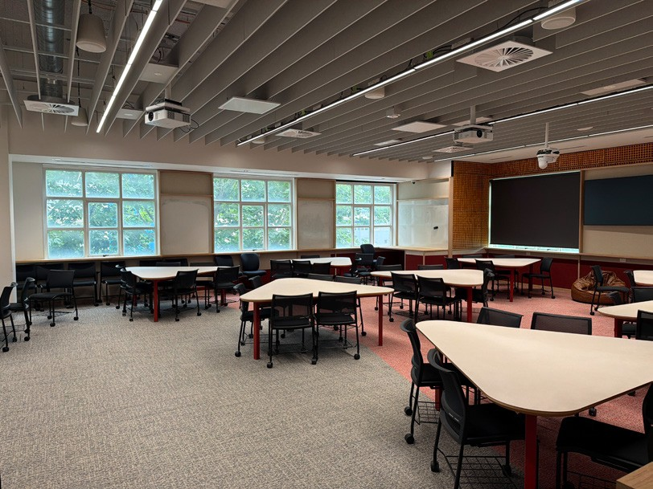
Example breakout space for oral presentations

Our volunteers have worked carefully to identify and adapt spaces throughout the building to make the conference as inclusive and accessible as
possible, including low-impact sensory spaces where attendees can watch live streams of the keynote presentations.

Where possible, we are using presentation rooms with adjustable lighting, while dedicated physical spaces will also be available for viewing and engaging with research posters throughout the conference that minimise crowding.

All-gender toilets will be available, and we will also have dedicated bathrooms without hand dryers for attendees who prefer a quieter sensory environment.

Ahead of the conference, we will continue to share short video tours of the presentation rooms and other key conference spaces so that members can familiarise themselves with the venue and available amenities, and have a clearer idea of what to expect before arriving.

2026

About this short form program
We are providing this short form of the program so presenters and attendees have an overview of the complete program. This short form program includes:

- the conference program include the keynotes, the first author and title of the oral presentations;
- the four poster presentation groups, including all named presenters and the title of their poster; and
- the judging forms including the criteria for the student oral presentation prize and the student poster presentation prize.

We will soon share with you our online full version of the program that will include:

- the abstracts and co-authors for each oral and poster presentation;
- video tours of the presentation spaces; and
- updated information about the social and mentoring events.

DAY 1 - MORNING
Thursday 3 December 2026

8:00 - 9:00am | Doors open: registration, Poster Group A set-up time, social time and equipment checks
9:00 - 9:30am | Quiet poster viewing session: Group A (presenters not required) | Level 5 UNESCO Arts Atrium
9:30 - 10:00am | Welcome to Country; ASfAR President’s address (A/Prof Josephine Barbaro); conference welcome; accessibility information and setting the scene for the day | Room Q230 + streaming
10:00 - 11:00am | KEYNOTE 1: Dr TC Waisman “Neurodivergence, Intersectionality & Justice: Responsive Approaches in Research and Practice” | Room Q230 + streaming
11:00 - 11:45am | Morning break + formal presenter-attended poster session for Group A from 11:10-11:40am + social activity stations | Level 5 UNESCO Arts Atrium + social activity stations
Session chairs to be confirmed and shared in advance | ORAL BREAKOUT SESSIONS - 10-minute presentation + 5-minute Q&A
Session chairs to be confirmed and shared in advance | Session 1  Room Q230 (theatre) + streaming  The autism research agenda and autistic leadership in research | Session 2  Room Q227  Identity and disclosure | Session 3  Room Q219  Autistic insights on education | Session 4  Room Q218  Mental health and mental health supports | Session 5  Room Q508  Autistic parents of autistic children: experiences and outcomes
11:45 - 12:00pm | Chris Paradisis*  Autism research priorities identified by the Autistic and autism communities: An updated systematic review | Erin Salmon*  Investigating Caregiver Disclosure of an Early Autism Diagnosis to their Young Children | Raechel Smart*  Looking Back, Moving Forwards: Autistic Young People’s Perspectives on Factors Influencing School Wellbeing and Attendance | Georgina Smith*  Lived Experiences of Autism Needs Assessments: Implications for Practice and System Improvement | Aida Karimi*  Parenting experiences of Autistic adults: a scoping review of strengths, challenges, and support needs
12:00 - 12:15pm | Abby Sesterka  Australian autism research funding: What  has – and what hasn’t – shifted in the last eight years? | Helen McLennan*  Young Neurodivergent Children’s Perceptions of Identity | Hayley Mitchelson*  Moving Schools: Frequency, Correlates, Reasons, and Move Types for Autistic and Non- Autistic Children | Emma Hinze*  Recognising Depression in Autistic Adults: Psychologists’ Autism-Informed Identification Practices | Melanie Heyworth*  “It doesn’t come as natural”: The role of double empathy in parenting Autistic children
12:15 - 12:30pm | Xiaoyi Yang*  The Unfortunate Lack of Neurodivergent-led Research in China and Suggestions for Culturally Sensitive Neurodiversity Research | Simon Bury  Autism Identity as a Buffer of Stigma: Testing the Rejection-Identification Model | Annette Carroll*  Understanding Autistic Student Well-Being at School: Student Perspectives through Inclusive Research | Ru Ying Cai  From Under-Recognition to Action: Building Adult Autism Assessment Capacity in Victorian Public Mental Health Services | Katherine Gore*  Mental and Physical Health Outcomes of Autistic Working Parents Assigned Female at Birth (AFAB)
12:30 - 12:45pm | Inga Koops*  “Unsilencible”: Autistic voices shaping participatory autism research | Phoebe Meldrum*  “I see [neurodivergence] as something that’s a really key part of my identity”: How late- diagnosed Autistic, ADHD, and AuDHD adults experience neurodivergent identity across the lifespan |  | Robyn Ball*  Improving mental healthcare for autistic adults: An Australian lived-experience study. | Sandra Thom-Jones  ‘No one ever asked me that’: Autistic parents’ reflections on their strengths
12:45 - 1:00pm | Lunch begins (fixed breakout-session buffer if needed)
1:00 - 1:15pm | Autistic research mentoring program  (45 minutes) | Lunch continues  Poster changeover - Group A removes and Group B sets up on Level 5 UNESCO Arts Atrium + Autistic mentoring program begins
1:15 - 1:45pm | Autistic research mentoring program  (45 minutes) | Lunch continues  Quiet poster viewing session for Group B (presenters not required) + social activity stations | Level 5 UNESCO Arts Atrium + social activity stations
Students eligible for the oral presentation prize are marked with an asterisk (*)

DAY 1 - AFTERNOON
Thursday 3 December 2026

Session chairs to be confirmed and shared in advance | ORAL BREAKOUT SESSIONS - 10-minute presentation + 5-minute Q&A
Session chairs to be confirmed and shared in advance | Session 6  Room Q230 (theatre)  Disability and barriers; late recognition of autism | Session 7  Room Q227  Physical activity and healthcare | Session 8  Room Q219  Early autism identification and  support | Session 9  Room Q218  Wellbeing, flourishing, and quality  of life | Session 10  Room Q508  Parent experiences, advocacy, and family interdependence
1:45 - 2:00pm | Chris Edwards  The burden of access: Accessibility barriers across everyday life for Autistic people and families | Daryll Archibald  Understanding Autistic Adults’ Experiences of Undertaking Physical Activity: A Rapid Qualitative Evidence Synthesis | Josephine Barbaro  Caregiver Experiences of Using ASDetect for the Early Identification of Autistic Infants and Toddlers | Melissa Black  Living the Good Life? A Blog-Based Study on Flourishing from the Perspective of Autistic Individuals | Jane Gibson*  Parent Advocacy Across Neurodevelopmental Conditions: A Meta-Ethnographic Review
2:00 - 2:15pm | Jac den Houting  Sometimes, all I can be is a body in a room: Understanding autistic disability dynamics | Michelle Wong*  Attendance Compulsory, Motivation Conditional. Satisfaction and Frustration of the Psychological Needs for Autistic Youth in Physical Education | Catherine Noakes-Duncan*  Examining General Practitioner’s Beliefs and Attitudes Towards Autism and Early Referral | Kathryn Ambrose  Insights from Autistic children and adolescents about what enables them to live ‘a good life | Yasmin Yassin*  You Don’t Know What Happens Behind Closed Doors: Somali Immigrant Parents’ Involvement in Their Autistic Children’s Education
2:15 - 2:30pm | Michalina Lisik*  It Gave Me Confidence to Advocate for How I Work Best: How Discovering an Autistic Identity in Adulthood Influences Employment and Career Outcomes | Monica Doherty*  Experiences of naturopaths who provide Complementary Medicine support autistic adults | Olivia Whalen  Maternal Biomarker Screening for Autism During Pregnancy: The Australian Autistic Community Support Reproductive Autonomy | Amanda Brignell  A systematic review of the quality of life in people with minimal spoken language | Nancy Sadka  Taageero Hore: East African Parents’ Experiences Raising an Autistic Child in Australia  – Qualitative Study
2:30 - 2:45pm | Laura Pecora  Perimenopause helped me start the new story that I now tell myself: Identity Reclamation During Perimenopause | Elly Greenwood*  Understanding emergency department care through the lived experiences of Autistic Children, Families and Staff | Hannah Waddington  Piloting a co-produced, neuroaffirming support for young autistic children | Olivia Arcangeli*  Psychological supports for quality-of-life outcomes in autistic adults: A systematic review and meta-analysis | Elinor Lim*  Family Dynamics in Autistic Students’ Higher Education Journeys
2:45 - 3:00pm | Afternoon tea begins (breakout-session buffer if needed)
3:00 - 3:45pm | Afternoon break + formal presenter-attended poster session for Poster Group B from 3:10-3:40pm + social activity stations | Level 5 UNESCO Arts Atrium + social activity stations
3:45 - 4:45pm | KEYNOTE 2: Dr Jess Taupou Mātauranga Māori and Autism Research: Centring Māori Knowledge, Values, and Experiences | Room Q230 + streaming
4:45 - 5:00pm | Concluding remarks and signposting for Day 2 | Room Q230 + streaming
5:00 - 6:00pm | Conference reception (Level 2 foyer) + Poster Group B remove posters
6:00 - 8:00pm | Conference dinner at the Last Jar (pre-registration required)
Students eligible for the oral presentation prize are marked with an asterisk (*)

DAY 2 - MORNING
Friday 4 December 2026

8:00 - 9:00am | Doors open: registration, Poster Group C set-up, social time and equipment checks
9:00 - 9:30am | Quiet poster viewing session: Group C (presenters not required) | Level 5 UNESCO Arts Atrium
9:30 - 9:55am | Acknowledgement of Country and setting the scene for the day (A/Prof. Matthew Harrison) | Room Q230 + streaming
9:35 - 9:45am | A/Prof Kathryn Coleman “Introducing the studioFive UNESCO arts education teaching, learning and research space” | Room Q230 + streaming
9:45 - 10:45am | KEYNOTE 3: Dr Samantha Cooms “Beyond Inclusion: Aboriginal Knowledges, Disability and the Future of Autism Research” | Room Q230 + streaming
10:45 - 11:30am | Morning break + formal presenter-attended poster session for Group C from 10:55-11:25am + social activity stations | Level 5 UNESCO Arts Atrium + social activity stations
Session chairs to be confirmed and shared in advance | ORAL BREAKOUT SESSIONS - 10-minute presentation + 5-minute Q&A
Session chairs to be confirmed and shared in advance | Session 11  Room Q230 (theatre)  Panel:  Advancing population-level autism research in Aotearoa New Zealand | Session 12  Room Q227  Adulthood, employment, and romantic relationships | Session 13  Room Q219  Neuroinclusive higher education and research training | Session 14  Room Q218  Burnout, camouflaging, and trauma | Session 15  Room Q508  Supporting autistic and non-autistic parents and pregnant people
11:30 - 11:45pm | PANEL PRESENTATION  Brodie Fraser Prevalence of the Intersections of Autism and Sexual and Gender Diversity amongst New Zealand Youth  Jessica Tupou Understanding Health Service Use for Autistic Māori: Insights from Population- Level Data and Lived Experience  Laurie McLay A Nationwide Study of School Enrolment, Attendance, and Educational Support for Autistic Students  Nick Bowden Understanding NEET (not in Employment, Education, or Training) Among Autistic Young People in Aotearoa New Zealand Troy Ruhe Pacific Ethnic Specific Identification of Pacific Autistic Peoples – a nationwide population study | Jasmine Gough*  Moral Distress in Autistic Employment: a Reddit Content Analysis | Ari Star*  Neurodivergent Students’ Experiences of Universal Design for Learning in Higher Education | Megan Clarey*  The Concealment Cycle: A Shame-Informed Framework for Understanding the Persistence of Autistic Burnout | Karri Thornton*  Perceived Social Support and Family Wellbeing in Parents of Primary School-Aged Autistic People
11:45 - 12:00pm |  | Subhashini Poornima Abeysekara* Organizational support for career development of autistic employees | Diana Tan  Guidelines for inclusive supervision for neurodivergent higher degree by research candidates: A Delphi study | Kassandrah Cooke*  Violence-Related Stress, Coping, and Cumulative Harm in Autistic and Non-Autistic Adults | Monique Clarke*  Design and Development of a Digitally-delivered Support Programme for Caregivers of Autistic Children
12:00 - 12:15pm |  | Jess Rowlings*  Next Level Collaboration: A social enterprise changing the game for the neurodivergent community | Lyndel Kennedy  Improving Supervision for Neurodivergent Graduate Researchers – Preliminary Findings from a Pilot Randomised Controlled Trial | Claire Brown  Intimate Partner Violence Exposure & Mental Health Outcomes among Autistic Women | Abigail Love  The Apex Hub: A Co-produced Knowledge Translation Model for Autism Research
12:15 - 12:30pm |  | Vicki Gibbs  Navigating online dating: A convergent mixed- methods study of autistic adults’ experiences of dating apps | Bahareh Afsharnejad  Belonging in Academia: A Scoping Review of Neurodivergent Staff Experiences in Higher Education | Meagan Bedelis*  Seen and Unseen: Parent and Adolescent Perspective on Masking in Autistic Girls with High Cognitive Ability | Rachel Grove & Tess Moodie  Our bodies are divergent… not just our brain: The perinatal care needs of Autistic people
12:30 - 12:45pm | Lunch begins (fixed breakout-session buffer if needed)
12:45 - 1:00pm | Lunch continues + poster changeover - Group C removes and Group D sets up on Level 5 UNESCO Arts Atrium + social activity stations | Level 5 UNESCO Arts Atrium + social activity stations
1:00 - 1:30pm | ASfAR AGM and committee elections -  Room Q230 | Lunch continues + ASfAR AGM begins
1:30 - 2:00pm | ASfAR AGM and committee elections -  Room Q230 | Lunch continues  Quiet poster viewing session for Group D (presenters not required) + social activity stations | Level 5 UNESCO Arts Atrium + social activity stations
Students eligible for the oral presentation prize are marked with an asterisk (*)

DAY 2 - AFTERNOON
Friday 4 December 2026

Session chairs to be confirmed and shared in advance | Session 16  Room Q230 (theatre)  Inclusive and co-produced research | Session 17  Room Q227  Aging and older adults’ experiences, accessibility of healthcare | Session 18  Room Q219  Education and childhood social relationships | Session 19  Room Q218  Individualising support and intervention | Session 20  Room Q508  Sensory experiences and interoception
2:00 - 2:15pm | Hayley Clapham*  Roadmap to strengthen autistic co-production and co-leadership in autism research | Titus Yim*  A Systematic Review of Functioning, Development, Wellbeing and Life Experiences in Middle and Old Aged Autistic Adults | Kate Simpson  Developing national guidance for inclusive physical school environments for Autistic students: A co-design approach | Jessica Paynter  Are Autism Adaptations Just Good Therapy? Autistic and Non-Autistic Adults’ Perceived Helpfulness of Therapy Adaptations | Kiera Adams*  Associations Between Autism and Self-Reported Dimensions of Interoception
2:15 - 2:305pm | Katy Unwin  Methods to Support Non-Speaking Autistic People to Engage in Research: A Scoping Review | Katie Brooker  What do Autistic people want support workers to know about supporting them to access healthcare | Rebecca Vine Foggo  Exploring how autistic girls navigate peer relationships and social experiences during adolescence | Samantha Wright (Lewis)  Beyond Group Effects: Why Individual Outcomes Matter in Sleep Intervention Trials for Autistic Children | Rebecca Poulsen  I shape my world around my sensitivities: Auditory Experiences of Intermittently- and Non-Speaking Autistic Adults
2:30 - 2:45pm | Niki Welz & Hannah Badenhop Evaluating participatory co-design with a National Autistic Advisory Group | Kitty-Rose Foley  Capacity building approaches in health care with autistic people with intellectual disability | Carolina Orellana  What makes a school good: protective factors in autistic students, Mapuche and Māori | Dianne Blackwell  Shared Perspectives on Emotion Regulation Support Needs Across the Autism Community | Chi Yhun Lo  Everyday listening experiences for neurodivergent adults: the role of context and control
2:45 - 3:00pm | Rachelle Wicks  Development of the Autism CRC Community Forum Guidance |  | Clare Kermond  How Autistic secondary students perceive their teachers and what impact this has on their experience of school | Lauren Lawson  Mapping Mental Health Profiles in Autistic Adults to Personalise Psychological Support | Heivet Hernandez Perez  Toward Accessible Hearing Assessments: Autistic Perspectives from Clinical and Research Contexts
3:00 - 3:15pm | Afternoon tea begins (breakout-session buffer if needed)
3:00 - 3:45pm | Afternoon break + formal presenter-attended poster session for Group D from 3:10-3:40pm + social activity stations | Level 5 UNESCO Arts Atrium + social activity stations
3:45 - 4:45pm | KEYNOTE 4: A/Professor Iliana Magiati Autistic people’s safety across the lifespan: What do we know and where should autism research go next? | Room Q230 + streaming
4:45 - 5:00pm | Awards presentation and conference close | Room Q230 + streaming
5:01pm | Poster Group D remove posters

Students eligible for the oral presentation prize are marked with an asterisk (*)

Poster Presentation Schedule
Shedulling notes:
- We have 119 active poster presentations have been scheduled across four sessions: A (30), B (30), C (30) and D (29). This is an ASfAR record so we have had to organise the posters into four groups.
- Please see the conference program for poster set up and pack down times – we ask you to please be mindful of your fellow poster presenters and pack down your poster in your allocated time.
- We will have dedicated volunteers on hand to help with our transition processes between groups.
- The program also contains dedicated quiet poster viewing times for each group but presenters are not required to be present for these sessions.
- Students eligible for the poster presentation prize are marked with an asterisk (*)

Poster Session A
Thursday 3 December 2026, 11:10–11:40am
Level 5 UNESCO Arts Atrium • 30 posters

First listed presenter | Additional presenters | Your stand number | Poster title
Ashley von Arx* | Jessica Bayes | 1 | Facilitating care for Autistic Individuals: The role of naturopaths in Australian clinical practice.
Belinda Fuss | Robyn Young; Valerie Forrest | 2 | A systematic review of autism training programs provided to emergency services and their outcomes.
Bahareh Afsharnejad | Rebecca Grummet; Rhys Parsons*; Alyssa Carrara; Lyndsay Humphries; Alexia Jurkowski; Elinda Lee; Sonya Girdler | 3 | Examining the Feasibility of a wellbeing-focused Art Program for Autistic High School Students
Benjamin Jones* | Elinda Ai Lim Lee; Maya Hayden-Evans; Bahareh Afsharnejad; Ben Milbourn; Sven Bölte; Sonya Girdler | 4 | Scaling up SCHOOL KONTAKT™ Social Skills Group Training Program: Extended Evaluation in Australian High Schools
Caitlin Hughes* | — | 5 | Neurodivergent-affirming mental health care: insights from autistic adults and allied health professionals
Catherine Wing-Chee So* | Xue-Ke Song; Samson Lam | 6 | Targeting Resilience in Chinese Parents of Autistic Children: Stress Variables and Profile-Specific Intervention Outcomes
Diana Tan | Ari Star*; Tristan Woodington; Patrick Dwyer; Liz Pellicano | 7 | “The structure is very normative”: Experiences of Autistic and/or ADHD staff working at Australian universities
Emmanuel Massay* | Laura Pecora; Sarosha Pillay; Mark Stokes; Karim Manji | 8 | Knowledge and Awareness of Autism in Tanzania: Perspectives of Parents of Autistic Children.
Francis Kewene* | — | 9 | Holding lived experience: Kaupapa Māori theatre wānanga as Indigenous research methodology in autism research contexts
Georgia Horsburgh* | Iliana Magiati; Murray Maybery; Lauren Taylor; Serena Cribb; Michael English | 10 | Development of a Neuroaffirming, DSM-5-TR-Aligned Caregiver-Report Questionnaire of Autistic Traits in Children: A Community-Engaged Multi-Phase-Study

Poster Session A
Thursday 3 December 2026, 11:10–11:40am
Level 5 UNESCO Arts Atrium • 30 posters

First listed presenter | Additional presenters | Your stand number | Poster title
Gilly-Elle McKeown | Claire M. Brown; Darren Hedley | 11 | Autistic Priorities for the Delivery of Effective Mental Health Support
Heivet Hernandez Perez | Mathew O'Donohue; Adrian KC Lee; Rebecca Poulsen; David McAlpine | 12 | Loudness perception of speech-in-noise in Autistic and non-autistic adults
Jessica Wheadon* | Bahareh Afsharnejad; Maya Hayden-Evans; Jaroslaw Hryniewicki; Tele Tan; Sven Bölte; Sonya Girdler | 13 | Evaluation of a chatbot designed to assist autistic adolescents with SCHOOL KONTAKT™: an exploratory mixed-methods study
Jodie Smith | Caroline Nadebaum; Kypros Kyprianou; Katrina Harris | 14 | The Participation Readiness Evaluation Protocol checklist to individualise autism assessment for children with complex needs
Lauren Denusik | Noor Chehayber; Jess Reynolds; Rachelle Wicks; David Trembath; Kandice Varcin | 15 | Consulting Young Children with Neurodevelopmental Conditions: Exploring Inclusive Methods and Approaches
Laurie McLay | Taylor Scott; Monique Clarke*; Carla Wallace-Watkin; Hannah Waddington; Jessica Tupou; Troy Ruhe; Lee Patrick; Caroline Donovan; Robert Ware | 16 | Self-Directed, Caregiver-Mediated, Digitally-delivered Supports for Autistic Children: A Systematic Review
Monica Doherty* | Janet Schloss; Kitty-Rose Foley | 17 | The experiences of autistic adults engaging with naturopaths for Complementary Medicine support
Nancy Sadka | Amanda Richdale; Xia Li; Josephine Barbaro; Perrin Date | 18 | Sleepless and Struggling: Unpacking the Link Between Sleep and ADHD-Related Traits in Autistic Toddlers
Nerelie Freeman | Chiara McDowell; Gordon Wu; Mirette Keriakes | 19 | The Lived Experiences of Self-Diagnosed Autistic Adults
Olivia Bruce* | Wan H. Sim; Elizabeth Nicolaou; Aspasia Stacey Rabba; Anthony F. Jorm; Marie B. H. Yap | 20 | Parent perceptions of the acceptability of a co-designed online parenting program for internalising problems in autistic children: A qualitative study
Qi Sheng Tan* | Alliyza Lim; Robyn Young | 21 | Eye, Head and Facial Cues Underlying Deception and Credibility Judgements in Autistic and Non-Autistic Individuals
Rhys Parsons* | Alyssa Carrara; Sonya Girdler; Bahareh Afsharnejad | 22 | Exploring Social Learning Factors for Autistic Adolescents
Samantha Playford* | Emma Axelsson; Ami Eidels; Laura Roche; Alyssa Quinn*; Madeleine Gale | 23 | Associations Between Screen Time, Sleep, And Language Development In Preschool-aged Autistic Children
Samantha Whybrow* | Ben Milbourn; Bahareh Ashfarnejad; Connie Kasari; Sven Bölte; Sonya Girdler | 24 | Participation and well-being in primary school recess: Bringing together autistic children’s and parent perspectives
Shui Wong* | Martin Downes; Hali van Niel; Amanda Brignell; Angela  T. Morgan | 25 | Speech-generating devices for children with complex communication needs: a systematic review and meta-analysis.
Rebecca Poulsen | Ari A. Star; Elizabeth Pellicano; Heivet Hernandez- Perez; David McAlpine; Diana Weiting Tan | 26 | Understanding Autistic Listening: Contextual and Affective Dimensions of Sound Perception
Stephanie Malone | Nicole Dargue; Aida Hurem | 27 | “I Needed to be Able to See”: Autistic Adults Perspectives of Learning and Using Mathematics
Tonya Agostini* | — | 28 | Do children with autism learn second language words faster? A group comparison study
Vicki Gibbs | Abigail Love; Chris Edwards; Lana Wheatfill; Natalie Pyszora; Debra Smith | 29 | Building autism-informed practitioner capability in countering violent extremism contexts: Evaluation of a national Community of Practice
Yu Shi* | — | 30 | School connectedness for autistic adolescents: Amplifying grassroots perspectives in Chinese schools

Poster Session B
Thursday 3 December 2026, 3:10 – 3:40pm
Level 5 UNESCO Arts Atrium • 30 posters

First listed presenter | Additional presenters | Your stand number | Poster title
Abigail Love | Louise White*; Melanie Carrier; Chris Paradisis*; Clara Haas; Rebecca Shields; Alex Grantham; Ru Ying Cai; Chris Edwards; Vicki Gibbs | 1 | Side by Side: Co-producing a Peer Mentor Transition Program for Autistic Youth and Families
Alison Deal* | Iliana Magiati; Diana Tana; Chris Edwards; Laura Crane; Dawn Adams; Samuel Arnold; Emeline Han; Caroline Hearst; Melanie Heyworth*; AJ Johnston; William Mandy; Jacqui Price | 2 | Post-Identification Support Needs Among Autistic Adolescents in Australia: Preliminary Findings From a Qualitative Study
Amy Chen* | Mani Ekambaram; Finn Gilroy; Noren Hasmun; Ben Daniel Motidyang | 3 | Caring for autistic children’s oral health in Aotearoa New Zealand – caregivers’ perspectives
Ari Star* | Diana Tan; Alice Chik | 4 | Neurodivergent Students’ Experiences with Universal Design for Learning in Higher Education: A Systematic Review
Catherine Wing-Chee So* | Gary Yu-Hin Lam; Li Wang; Xiaohan Li | 5 | Beyond Western Paradigms: Hong Kong Parents’ Multi-Dimensional Attitudes Toward Autism and Neurodiversity
Elisabeth Arnold* | — | 6 | Disabled by Design: Enhancing Accessibility for K-6 Educators
Emily De Sando* | Josephine Barbaro; Asher Mills; Marguerite Hawke; Gemma Davy | 7 | Autism Diagnosis Disclosure Among Caregivers of Young Children: Exploring Caregiver Motivations
Erika Clara Moelle* | Wan Hua Sim; Olivia Bruce*; Marie B. H. Yap | 8 | Culturally responsive practices in an online coach-assisted parenting program for internalising problems in autistic children
Gail Alvares | Christiane E. Kehoe; Sarah Pillar; Mirko Uljarević; Ru Ying Cai; Andrew J. O. Whitehouse; Sophie S. Havighurst | 9 | Emotion coaching for parents of young children diagnosed with autism: A feasibility pilot
Hannah Watson* | — | 10 | The communicative participation and language in a small sample of autistic preschool aged children.
Jesse Franklin* | Natasha Ziebell; Matt Harrison | 11 | Exploring school-belonging with autistic secondary students
Soumitra Das | Isuri Wimalasiri; Madeline Anderson; Alison Brinksma | 12 | Outreach Autism Diagnostic Assessment: A Neurodiversity-Friendly, Trauma-Informed Approach
Kate French | Holly Brown; Melanie Hall | 13 | Unmet Need to Rural Innovation: Building Accessible Autism and ADHD Assessment Pathways
Kathryn Ellis | Jessica Dumble | 14 | Autism Assessment in Later Life: The Older Persons Autism Liaison Service (OPALS)
Liam Spicer* | Alvita Sam | 15 | Autism and Psychedelic-Assisted Psychotherapy: World-first Clinical Guidelines, Emerging Evidence, and Research priorities
Mackenzie Sara* | Brodie Cooper; Jack Brett; Murray Maybery; Iliana Magiati; Diana Tan | 16 | Autistic Burnout Mediates the Associations Between Vulnerability Experiences, Stigma, Camouflaging, and Wellbeing in Autistic Adults.

Poster Session B
Thursday 3 December 2026, 3:10 – 3:40pm
Level 5 UNESCO Arts Atrium • 30 posters

First listed presenter | Additional presenters | Your stand number | Poster title
Melanie Muniandy | Charlotte O'Brien; Megan Clark; Amanda Richdale; Lauren Lawson | 17 | "Can I withstand this today?": A Qualitative Study on Resilience in Autistic Adults
Meredith Bryan* | Kate Simpson; Dawn Adams | 18 | South Asian Caregivers' Experiences of Obtaining a Diagnosis and Early Supports for their Autistic Children in Australia
Niki Welz | Hannah Badenhop | 19 | Co-designed online learning improves knowledge, confidence and self-efficacy for autistic adults
Olivia Lee* | Mark Stokes | 20 | Exploring the role of social functioning in the relationship between autistic traits and self- esteem in adolescent females
Patrick Dwyer | Emma Laird | 21 | Conceptualising and Understanding Attention in Autism and Misophonia
Phoebe Meldrum* | Aspasia Stacey Rabba; Beth P Johnson; Barbara Chuen Yee Lo | 22 | Knowing yourself, being yourself: Identity integration, authenticity, and psychological well- being in late-diagnosed Autistic adults
Qi Sheng Tan* | Alliyza Lim; Belinda Fuss; Michael Wenzel; Robyn Young | 23 | Sincerity Perception in Apologies: Apology Characteristics Matter More Than Autistic Traits and Empathy
Quanli Wang* | SO Wing-chee | 24 | Neurodiversity Attitudes Among Caregivers of Autistic Children in China
Samantha Wright | Lyndel Kennedy*; Emily Chan | 25 | Understanding the sleep support needs of autistic and ADHD higher education students
Sarah Poiner* | Jessica Paynter; Kristyn Sommer; Vicki Gibbs | 26 | Intimate Partner Violence Screening Measures: Scoping Review and the Co-Design of an Autistic-Informed Criteria
Sewnet Kebede* | Mohammed Alshawsh; Amanda Brignell; Katrina Williams | 27 | Can We Accurately Estimate Complex Communication Needs in Australian Children Using Existing National Data?
Tori Haar* | Diana Tan; Hayley Clapman*; Melanie Heyworth*; Wenn Lawson; Joanne Mahony; Liz Pellicano; Emily Hughes | 28 | "A long time to unravel": Late-diagnosed Autistic adults’ experiences of processing their Autistic identities
Ying Man Sung* | Robyn Young | 29 | Does Emotion Regulation Ability Predict Challenging Behaviour, Anxiety Symptoms, and Daily Functioning in Autistic Adolescents
Yong Zhang* | Katie Hooton; Sujata Saja; Emma Heydon; Barry Milne; Laurie McLay; Joanne Dacombe; Byron Rangiwai; Nicholas Bowden | 30 | Demographic, Family, Health, and Support Need Characteristics Associated with the Timing of Autism Diagnosis in New Zealand

Poster Session C
Friday 4 December 2026, 10:55 –11:25am
Level 5 UNESCO Arts Atrium • 30 posters

First listed presenter | Additional presenters | Your stand number | Poster title
Alana Haintz* | — | 1 | Social-Communication and Alexithymia: Associations with the Subjective Wellbeing of Autistic Adolescents
Alexandra Aulich | Jodie Smith; Melanie Muniandy; Katherine Pye; Cherie Green; Cathy Bent; Kristelle Hudry | 2 | What PlayConnect+ Staff “want for every child… fantastic friendships, great lives, great input into community”
Alyssa Quinn* | A. Quinn; E. Axelsson; M. Duncan; A. Eidels; M. Gale;  S. Playford | 3 | Associations between Screen Time & Cognition in Autistic Preschool-Aged Children: Links with Sleep and Physical Activity
Amanda Richdale | Lauren Lawson; Eric Morris | 4 | Adult sleep quality: The impact of autistic traits, psychological flexibility, arousal and intolerance of uncertainty.
Amanda Webster | Traci-Ann Garrad; Jade Lee | 5 | Examining interdisciplinary decision-making in support systems for autistic children
Kitty-Rose Foley | M Porter; A Giesberts; R De Greef; K Brooker; M Johnston; C Franklin | 6 | Trauma-transformative practice with health services supporting people with intellectual disability, including autistic people
Chenai Mupotsa-Russell* | — | 7 | What Counts as Learning? Embodied, Relational, and Culturally Diverse Ways of Knowing in Autistic Learning
Chen Xi Lim* | — | 8 | Gender differences in effects of alexithymia on wellbeing and affect in autistic youth
Ellen Richardson* | Lauren Lawson; Rebecca Flower; Simon Bury; Patrick Dwyer; Jennifer Spoor | 9 | Separate or combined? Lived experience perspectives of autism and ADHD
Elinor Lim* | — | 10 | Fraud, Accessible Participation, and Community Involvement: Reflections from Doctoral Research
Emma Hinze* | Rachelle Wicks; Zheng Yen Ng; Libby Groves; Teena Caithness; Taryn Jones; David Trembath | 11 | From inclusive principles to practice: Engaging autistic people with high and/or complex support needs
Fiona Roberts* | — | 12 | What Campaign Materials Ask Voters to Do: An Autistic-Led Visual and Multimodal Analysis
Georgina Smith* | Jessica Smith; Robyn Middleton; Niki Welz | 13 | Improving Access to Minor Healthcare Procedures for Adults with Complex Needs Through Sensory-Safe Approaches.
Heivet Hernandez Perez | Kurt Shulver; David McAlpine; Rebecca Poulsen | 14 | Perceptual anchoring in Autistic and non-autistic listeners: A statistical learning approach using auditory textures
Jayne Garrod* | — | 15 | The lived experiences of neurodivergent birthing people: negotiating medical discourses and resisting neuronormativity
Jessica Wheadon* | Patrice Whitehorne-Smith; Elinda Ai Lim Lee; Chris Howarth; Sonya Girdler | 16 | Evaluating a music video project for autistic adults: a realist approach
Jia Ke* | Katherine Johnson; Simon De Deyne; Shuting Li | 17 | Autistic Traits Are Associated with Stronger Sensorimotor Grounding of Abstract Concepts

Poster Session C
Friday 4 December 2026, 10:55 –11:25am
Level 5 UNESCO Arts Atrium • 30 posters

First listed presenter | Additional presenters | Your stand number | Poster title
Kirsten Perrins* | Katie Wood; Rachel Jellett; Monique Seymour | 18 | Neurodiversity Affirming Practice: Educational Needs of Australian Psychologists working with Autistic and ADHD adults
Liam Spicer* | — | 19 | Schemas in Autistic and ADHD Individuals: Impact, Changing the Narrative, and Therapy Considerations
Louise White* | Dawn Adams; Kate Simpson; Stephanie Malone | 20 | What Is Important for Autistic Students’ Post-School Transition? A Q-Sort Study With School Staff
Melanie Heyworth* | Diana Weiting Tan; Elizabeth Pellicano | 21 | The impact of “harmful behaviours” on parents of Autistic children
Olivia Bruce* | Wan H. Sim; Elizabeth Nicolaou; Anthony F. Jorm; Aspasia Stacey Rabba; Katrina Williams; Marie B.  H. Yap | 22 | The feasibility and acceptability of the Partners in Parenting Kids-Autism program: A coach-supported, online parenting program targeting child internalising problems
Phoebe Meldrum* | Aspasia Stacey Rabba; Beth P Johnson; Barbara Chuen Yee Lo | 23 | “A third space, a chance to connect with other people like me”: Experiences of Autistic and AuDHD adults participating as advisors in research
Qi Sheng Tan* | Belinda Fuss; Alliyza Lim; Michael Wenzel; Robyn L. Young | 24 | Verbal and Facial Expressions of Apology: The Influence of Autistic Traits and Apology- Sincerity Perception
Quanli Wang* | SO Wing-chee | 25 | Multilevel Stigma Among Caregivers of Autistic Children in China
Ravini Jayawardena* | Andrea Reupert; Aspasia Stacey Rabba; Alexandra Ure; Clayton VIC | 26 | Exploring Preferences of Immigrant Families When Accessing Autism-Related Services for Their Children: A Scoping Review
Rundong Wang* | Susumu Yokota | 27 | Personal values, knowledge, and attributional judgements as predictors of autism attitudes and volunteer intention
Vanita Sharma* | Azizuddin Khan | 28 | Static and Dynamic Emotion Stimuli: Differential Influence on Facial Emotion Recognition in Autistic Children
Yasmin Szabados* | Robyn Young | 29 | Post-traumatic Stress Disorder in Autistic Adults: The Impact of Rigidity and Related Cognitions
Yasmin Yassin* | Aspasia Stacey Rabba; Levita D’Souza; Ifrah Abdullahi | 30 | “Nobody Told Me About Our Rights”: Immigrant parents’ involvement experiences in Their Autistic Children’s Education

Poster Session D
Friday 4 December 2026, 3:10 - 3:40pm
Level 5 UNESCO Arts Atrium • 29 posters

First listed presenter | Additional presenters | Your stand number | Poster title
Abigail Love | Lauren Robinson; Lindsey Ogle; Qianhan Xiong; AJ Krzywicki; Samuel Johnson; Iris Chalk; Rebecca Lawrence; Ollie Lavender; Kameron Breedlove; Temilade Akinwolere; Lisa Ruble | 1 | Co-Producing Transition Support: Autistic Lived Experiences Informing Student Voice in a School-to-Adulthood Intervention
Alexander Ma | Siu Kit YEUNG | 2 | What's Going on in Chinese Neurodiversity Research? A Thematic Analysis of Neurodiversity Research(ers) in China
Amanda Webster | Mark Carter; Jennifer Stephenson | 3 | Developing ADMIT: A tool to support evidence-informed decision-making in school environments
Bahareh Afsharnejad | Devdan Ooi; Lyndsay Humphries; Sonya Girdler | 4 | Knowledge, Contact, and Attitudes Towards Neurodiversity Among Australian University Staff and Students
Bahareh Afsharnejad | Alexia Jurkowski; Lyndsay Humphries; Rhys Parsons*; Alyss Carrara; Rebecca Grummet; Elinda Lee; Sonya Girdler | a 5 | More Than Art: Co-Designing a Wellbeing Program with Autistic Adolescents
Belinda Fuss | Robyn Young; Tammie Foster | 6 | Do autistic people use emergency services more than non-autistic people?
Benjamin Bailey | Emma Beardsley; Karen Ray | 7 | Community perspectives and experiences of early writing instruction involving Autistic children
Dawn Adams | Megan Walsh; Timea Molnar; Simon Bury; Halle Wiblen; Chris Paradisis* | 8 | Who Is Missing from Autism Research? Demographic Reporting and Representation in Australian Autism Studies
Delia Kan | — | 9 | What Would Actually Help: Autistic Adults’ Visions for AI Support to Meet Workplace Needs
Eleni Demetriou | Kaylena Ehgoetz Martins; Simon Lewis; Adma Guastella | 10 | An examination of the role of executive cognitive demands, on gait control in Autism
Emily Spackman | Lacey Chetcuti; Mirko Uljarević | 11 | Disentangling overlapping presentations repetitive motor behaviours and sensory seeking: an individual differences approach
Gail Alvares | Sarah Pillar; Kandice Varcin; Mirko Uljarevic; Rebecca Kuzminski; Andrew J. O. Whitehouse | 12 | Feasibility and acceptability of a group program targeting well-being and resilience in siblings of autistic children
Jessica Bayes | Janet Schloss; Andrew Cashin | 13 | An investigation into the diets, wellbeing and lifestyle habits of Autistic Adults: A Cross sectional study
Kristelle Hudry | Jodie Smith; Alexandra Aulich; Melanie Muniandy; Cherie Green; Katherine Pye; Cathy Bent | 14 | “When You’re Struggling and Someone Says, ‘Take my hand, I’m here…’: Perceived Benefits of PlayConnect+
Nancy Sadka | Xia Li; Amanda Richdale; Josephine Barbaro; Alex Haschek; Perrin Date; Lauren Lawson | 15 | AuDHD and Autistic Groups: Network Analysis Between ADHD Traits in Toddlers and Pre-schoolers
Natalie White-Wall | Alison Nuske; Rosemarie Herbert | 16 | Navigating the Peaks and Valleys: Understanding Neurodivergent Student Experiences of WIL
Nathan Caruana | Terry Goetz; Patrick Nalepka; Elizabeth Pellicano | 17 | “Breaking down a barrier.” Autistic young people see virtual reality as a tool to overcome social barriers, but not a replacement for in-person interactions.

Poster Session D
Friday 4 December 2026, 3:10 - 3:40pm
Level 5 UNESCO Arts Atrium • 29 posters

First listed presenter | Additional presenters | Your stand number | Poster title
Noheed Ali | Mark Stokes | 18 | Predicting Wellbeing in Autistic Adolescents : The Relative Contributions of Positive Affect and Self-esteem
Patrick Dwyer | Melissa Gilbert; Kelsey Philpott-Robinson; Jenny Heriot; Drew Heriot | 19 | Beyond Social Skills Training: Confidence and Enthusiasm in a Neurodiversity-Affirming Theatre Program
Ru Ying Cai | Chris Edwards; Abigail M. A. Love; Emily Russo; Vicki Gibbs | 20 | "More Human and People-Centered": Autistic Adults' and Parents' Perspectives on Employment in Small and Medium Enterprises
Sandra Thom-Jones | Susan Abel; Charlotte Brownlow | 21 | ‘It shouldn’t have to be so hard’: Autistic parents’ interactions with healthcare
Sara Passarini | Katherine Pye; Jodie Smith; Cherie C Green | 22 | Family well-being during primary school: Australian parents’ experiences of caring for their  Autistic children
Shuting Li | Anna Jevremovic; Katherine Johnson | 23 | No association between autistic traits and endogenous attention orienting in a novel naturalistic task
Simon Bury | Ellen K. Richardson; Patrick Dwyer; Jennifer R. Spoor; Rebecca L. Flower | 24 | Autism + ADHD = What? Preferences, Acceptability, and Perceived Offensiveness of Emerging Terms
Simon Bury | Jennifer R. Spoor; Darren Hedley; Naomi Schreuer; Eynat Gal; Michal Waisman-Nitzan | 25 | Understanding Workplace Outcomes in Autism: The Mediating Role of Workplace Barriers
Jodie Smith | Yimin Wang; Katherine Pye; Samantha Turner; Rachel Davenport; Ella O’Sullivan; Lanah Vasilevski; Kanisha Patel; Ijaz; Josephine Barbaro; Chloe Wong; Catherine Bent | Rabia 26 | Feasibility, Acceptability and Effectiveness of More Than Words® Early Support Program for Migrant Australian Families
Susumu Yokota | Kohei Sakaki | 27 | Autistic traits moderate the relationship between familiarity difference of prosocial allocation behavior and executive function
Teresa Rani V S | Pramod Kumar | 28 | From Lived Experience to Policy Formulation: Using Special Educators’ Narratives for Special Education Policy in India
Wayne Arnold | Vicki Bitsika; Christopher F Sharpley | 29 | Clarifying Masking: Conceptualising Autism Concealment

Student Presentations and Poster Prizes
Instructions for Session Chairs, Associate Chairs and Students
Two prizes will be awarded during the conference: The Lawrie Bartak Prize for the best student poster presentation, and the Margot Prior Prize for the best oral presentation. Recipients of these awards will receive $250 AUD and a certificate. Award recipients and honourable mentions will be announced during the final conference session, 4:45pm on Friday 4th December 2026.
Eligibility:
- Students must be the primary presenter and enrolled at a tertiary institution the time of submission
- Undergraduate, honours, masters, and HDR students are eligible
- Students must hold an active ASfAR student membership
Preparing your Presentation:
Students may like to review the evaluation criteria below when preparing their presentation. Please note the criteria differ slightly for oral and poster presentations. For student posters, please ensure you also submit a PDF version of your poster as per the emailed instructions.
Judging:
Session Chairs, members of the ASfAR 2026 conference organising committee, and members of the ASfAR Scientific Committee will provide these ratings. If you have been asked to rate presentations, please collect printed copies of the evaluation forms at the conference sign-in desk, and return your completed forms there immediately after your judging session. Please note there are separate forms for oral and poster presentations, and digital versions of the forms are also available if you prefer.

The evaluation criteria for students’ posters and oral presentations are provided below.

Student Presentations and Poster Prizes

Presentation Title:
Student Author(s):
Affiliation:

Comments:

Thankyou for your time!

Conflict of Interest declaration:
I confirm that I do not have supervisory relationship, current collaboration or other conflict of interest with this student or any of their coauthors?
□
Student Oral Presentation Evaluation Form
If you are a session chair or have been asked to evaluate student oral presentations, please complete the form below immediately after each presentation. All student presentations are marked in the programme with an ‘*’.
Judges: please rate all presentations on the following criteria:
Score ratings:
6 = outstanding/exceptional 5 = excellent 4 = above average 3 = average 2 = acceptable but below average 1 = poor
Criteria |  | Score
Scientific quality | The research is methodologically sound and demonstrates appropriate scientific rigour
Originality or significance | The research addresses an important question and contributes new knowledge or insights
Clarity of communication | The research aims, methods, findings and conclusions are presented clearly and understandably
Participatory research | Community members were included in the design, data collection, analysis and interpretation stages
Structure and timing | The presentation is logically organised, easy to follow, and delivered within the allocated time
Slide quality | Slides are clear, visually effective, and support key messages
Delivery and audience engagement | The presenter communicates clearly and conveys enthusiasm for the research, through their preferred communication method
Answering questions | The presenter responds accurately and thoughtfully to questions, demonstrating understanding of the research. Presenters who need additional time to respond (e.g., when using AAC), may instead explain how they will respond to questions after the session.
Total Score

ORAL

Student Presentations and Poster Prizes
Student POSTER Presentation Evaluation Form
If you have been asked to evaluate student posters, please complete the form below immediately after viewing the poster. All student presentations are marked in the programme with an ‘*’.

Poster Title:
POSTER
Poster Session: A Thu AM B Thu PM C Fri AM D Fri PM
Student Author(s):
Affiliation:
Comments:

Thankyou for your time!

Conflict of Interest declaration:
I confirm that I do not have supervisory relationship, current collaboration or other conflict of interest with this student or any of their coauthors?
□

Judges: please rate all presentations on the following criteria:
Score ratings:

6 = outstanding/exceptional | 5 = excellent | 4 = above average
3 = average | 2 = acceptable but below average | 1 = poor

Criteria |  | Score
Scientific quality | The research is methodologically sound and demonstrates appropriate scientific rigor
Originality or significance | The research addresses an important question and contributes new knowledge or insights
Clarity of communication | The research aims, methods, findings and conclusions are presented clearly and understandably
Participatory research | Community members were included in the design, data collection, analysis and interpretation stages
Visual design and readability | The poster is visually appealing, well organised and easy to read
Logical flow | Information is structured logically, making the research easy to follow
Total Score

2026

